Weekly Coding Exercise #5

Task:

“The task is to take a common game programming problem, research the formula required to solve the problem, and convert that solution into UnityScript code.”

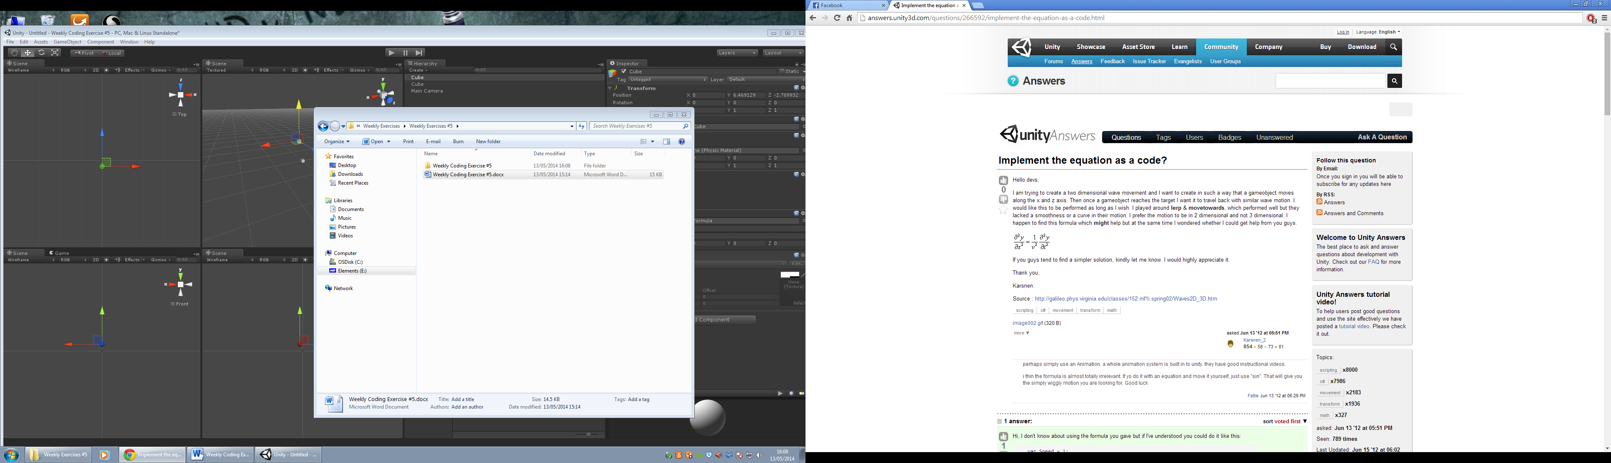

1. var Speed = 1;
2. var Amplitude = 1;
3. var TargetPos : Vector3;
5. function Update () {
6. transform.position.y = Mathf.Sin((Mathf.Sqrt((TargetPos.x-transform.position.x)*(TargetPos.x-transform.position.x) + (TargetPos.z-transform.position.z)*(TargetPos.z-transform.position.z)))*Speed) * Amplitude;

I do not credit the above code and the link below shows where I received this; however I used the formula to understand how the formula acts within Unity, and found that this allows the boxes to move positions upon play in Unity.

http://answers.unity3d.com/questions/266592/implement-the-equation-as-a-code.html

Development Log:

|  |  |  |  |  |  |  |
| --- | --- | --- | --- | --- | --- | --- |
| Exercise | Task | Date | Start | End | Interruptions | Hours |
| Weekly Exercise #05. |  | 09/05/2014 |  |  |  |  |
|  | Decided the problem. |  | 1:00 | 1:03 |  | 0.03 |
|  | Research for formula. |  | 1:03 | 1:33 |  | 0.30 |
|  | Convert to code and test. |  | 1:33 | 2:05 |  | 0.32 |
|  | Write solution to problem. |  | 2:05 | 2:15 |  | 0.10 |